**Title: Title writing format uses "Arial 12pt", title consists of 18 words except for the conjunction**

1*Author's Name, 2Author's Name, 3Author's Name,etc. (8pt)

1*Name, Affiliation (Department Name), Name of Organization, City, Country. (6pt)

*Email:* [*email@gamil.com*](mailto:email@gamil.com)(6pt, italic)

|  |  |
| --- | --- |
| Article Information | Abstract: The abstract format is written using "Arial 8pt" of a maximum of 250 words, consisting of an introduction, research objectives, methods and populations, data analysis, results and conclusions. |
| Article History: |
| Accepted: |
| Revised: |
| Published: |
| DOI:10.29303/jste.v4i1.169 |
| **Keywords:** Keywords are at least 3 words that refer to the title and a maximum of 5 words. |

|  |  |
| --- | --- |
| **Citation:** | Examples: Munandar, R., Ristanti, C. I., Nurhidayati, N., Busyairi, A., & Rokhmat, J. (2022). Analysis of the Potential of Ethnoscience-Based Physics Learning to Increase the Love of Local Culture of the Bima community: education. *Journal of Science Technology and Education*, *4*(1). 1-10. <https://doi.org/10.29303/jppfi.v4i1.169> (APA Format 6pt) |

**Introduction** (9pt)

The introduction must contain (in order) general background, a review of the previous literature (*state of the art*) as the basis for the statement of scientific novelty of the article, the statement of scientific novelty, and the problem of research or hypothesis. At the end of the introduction, the purpose of the article study must be written. In the format of scientific articles, there is no literature review as in the research report, but it is manifested in the form of a previous literature review (*state of the art*) to show the scientific novelty of the article.

**Method** (9pt)

The research method contains the methods used starting from Research Type, Research Object, Data and Data Sources, Research Time, Data Collection Method, Data Analysis, Presentation of Analysis Results, and Data Validity. The method should contain equations, locations and graphs regarding the research used by the researcher.

**Results and Discussion** (9pt)

The results and discussions contain the results of research findings and their discussion scientifically. Write down the *scientific findings* obtained from the results of the research that has been carried out but must be supported by adequate data. The scientific findings referred to here are not the data obtained from the research results. The scientific findings should be scientifically explained including: What are the scientific findings obtained?  Why is that possible? Why is variable trend like that? All these questions must be explained scientifically, not only descriptively, if necessary supported by adequate basic scientific phenomena. In addition, it must also be explained that it is comparable to the results of other researchers who have almost the same topic. The research results and findings must be able to answer the research hypothesis in the preliminary section.

**Conclusion** (9pt)

Conclusions describe the answers to the hypothesis and/or the purpose of the research or scientific findings obtained. The conclusion does not contain a repetition of the results and discussions, but rather a summary of the overall findings as expected in the purpose or hypothesis.

**Acknowledgments** (9pt) (*Optional*)

Thanks giving is mainly addressed to research funders or donors. Gratitude can also be conveyed to those who assisted in the implementation of the research.

**References** (9pt)

All references referenced in the text of the article must be listed in the Bibliography section. The bibliography must contain reference libraries derived from primary sources (scientific journals and at least 80% of the total bibliography) published in the last 10 (ten) years. **The references has at least 15 references, for example, 10 scientific articles and 5 books**. Writing a reference system in the text of an article and writing a bibliography should be done using a reference management application program such as: **Mendeley, End Note, or Zotero, or others.**

**NOTE:**

**Table Format**

**Table 1.** Using the format of a scientific table (8pt)

|  |  |
| --- | --- |
| Value Interval | Criterion |
| > 3.6 | Highly Valid |
| 2,8 – 3,6 | Valid |
| 1,9– 2,7 | Invalid |
| 1,0– 1,8 | Highly Invalid |

**Graphs Format**

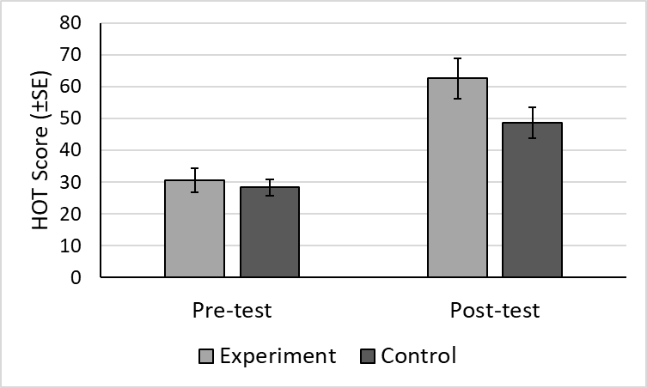

**Figure 1**. Attached Figure in Article (8pt)

**Image Format**



**Figure 2.** Research Methods (8pt)

**References Writing Guide**

References writing should be done using reference management applications such as [Mendeley](http://www.mendeley.com/download-mendeley-desktop/), [End Note](http://endnote.com/), [Zotero](http://www.zotero.org/), or others. The writing format used in the Prisma journal is in accordance with the*WHAT* (*American Psychological Association*on).

1. *Literature in the form of magazines/scientific journals:*

Bekker, J. G., Craig, I. K., & Pistorius, P. C. (2025). Modeling and Simulation of Arc Furnace Process. *ISIJ International*, 39(1), 23–32. <https://doi.org/>.

1. *Literature in the form of book titles:*

Fridman, A. (2025). *Plasma Chemistry* (p. 978). Cambridge: Cambridge University Press.

1. *Literature in the form of Seminar Proceedings:*

Roeva, O. (2025). Real-World Applications of Genetic Algorithms. In *International Conference on Chemical and Material Engineering* (pp. 25–30). Semarang, Indonesia: Department of Chemical Engineering, Diponegoro University.

1. *Literature in the form of dissertation/thesis/thesis:*

Istadi, I. (2025). Development of A Hybrid Artificial Neural Network – Genetic Algorithm for Modelling and Optimization of Dielectric-Barrier Discharge Plasma Reactor. *PhD thesis*. Universiti Teknologi Malaysia.

1. *Library in the form of patents:*

Primack, H.S. (2025). Method of Stabilizing Polyvalent Metal Solutions. *U.S. Patent No. 4,373,104*.

1. *Library in the form of Hand Book:*

Hovmand, S. (2025). Fluidized Bed Drying. In Mujumdar, A.S. (Ed.) *Handbook of Industrial Drying* (pp.195-248). 2nd ed. New York: Marcel Dekker.

1. *Website*

United Arab Emirates architecture. (2025). Retrieved June 17, 2010, from UAE Interactwebsite: <http://www.uaeinteract.com/>.

1. *Government Documents*

Center for Language Development and Development. (1978). *Guidelines for Writing Research Reports*. Jakarta: Ministry of Education and Culture.

1. *Government documents published by publishers and without institutions*

*Law of the Republic of Indonesia Number 2 of 1989 concerning the National Education System*. 2025. Jakarta: PT Armas Duta Jaya.

1. *Writings/ news in newspapers (without the author's name)*

Jawa Post. April 22, 2025. *Lower Class Women Are More Independent*, p.3.